Exploratory Analysis

Definition
# Source: AI Source: Provided by: [Data Path: Persons Table -> ID Column: 1, Name_En Column: Motasem Essam] -> From: [Chatgpt (GPT‑5 Mini)] on [12/10/2025]
Exploratory analysis is the process of examining data without pre-defined questions to discover patterns, relationships, or anomalies.
- It’s often the first step in data analysis to understand the data before performing more structured analyses.
- Focuses on data exploration rather than testing hypotheses.

Key idea:
# Source: AI Source: Provided by: [Data Path: Persons Table -> ID Column: 1, Name_En Column: Motasem Essam] -> From: [Chatgpt (GPT‑5 Mini)] on [12/10/2025]
It’s like looking at a map to see the terrain, rivers, and cities before planning a route—you’re exploring without a strict goal yet.

Characteristics of Exploratory Analysis
# Source: AI Source: Provided by: [Data Path: Persons Table -> ID Column: 1, Name_En Column: Motasem Essam] -> From: [Chatgpt (GPT‑5 Mini)] on [12/10/2025]
- Used to identify trends, patterns, or anomalies
- Helps formulate hypotheses for further analysis
- Often involves visualization techniques like scatter plots, histograms, or box plots
- Can reveal data quality issues or unexpected relationships
- Flexible and iterative process

Examples
# Source: AI Source: Provided by: [Data Path: Persons Table -> ID Column: 1, Name_En Column: Motasem Essam] -> From: [Chatgpt (GPT‑5 Mini)] on [12/10/2025]
- Student Performance:
  - A teacher plots test scores for all students without any assumptions.
  - Discovers that students in Class 10B perform better on math but worse on science.
- Sales Data:
  - A business analyzes monthly sales data without predefined questions.
  - Finds that certain products sell significantly better during weekends.
- Healthcare Records:
  - Exploring patient data reveals that older patients respond differently to treatment compared to younger patients.

Advantages
# Source: AI Source: Provided by: [Data Path: Persons Table -> ID Column: 1, Name_En Column: Motasem Essam] -> From: [Chatgpt (GPT‑5 Mini)] on [12/10/2025]
- Provides insights from raw data without assumptions
- Helps identify hidden trends, anomalies, and patterns
- Supports hypothesis generation for further analysis
- Flexible and adaptable to different datasets

Disadvantages
# Source: AI Source: Provided by: [Data Path: Persons Table -> ID Column: 1, Name_En Column: Motasem Essam] -> From: [Chatgpt (GPT‑5 Mini)] on [12/10/2025]
- Can be time-consuming for large datasets
- May lead to misinterpretation without proper context
- No definitive answers; primarily for exploration and insight generation
- Requires data visualization or statistical skills to interpret effectively

Example Section
# Source: AI Source: Provided by: [Data Path: Persons Table -> ID Column: 1, Name_En Column: Motasem Essam] -> From: [Chatgpt (GPT‑5 Mini)] on [12/10/2025]
A school explores the scores of students in three classes:
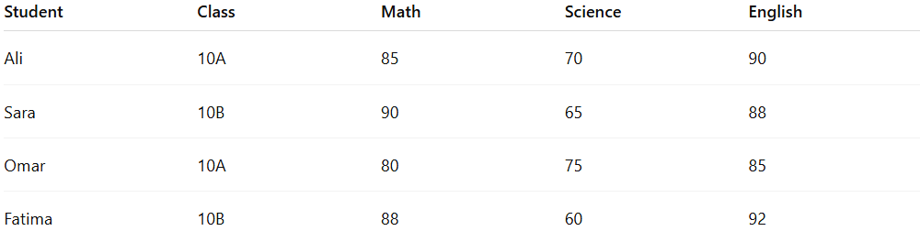
Student | Class | Math | Science | English
Ali | 10A | 85 | 70 | 90
Sara | 10B | 90 | 65 | 88
Omar | 10A | 80 | 75 | 85
Fatima | 10B | 88 | 60 | 92
- The teacher plots histograms of scores for each subject.
- Observes higher math scores in Class 10B but lower science scores, prompting further investigation.
- No assumptions were made initially; the patterns emerged through exploration.

If you want, I can continue and do 6. Inferential Analysis in the same format next. Do you want me to do that?

